Name: Ashley Cienciera
Date:
Hour: 4th and 5th
Career Field Experience

‘There is only one success--to be able to spend your life in your own way” Christopher Morley. This is the perfect quote related my experience in Career Field Experience because I am always working independently. One part of my job that I really enjoy is that when I come into work, I get straight to work, and there is plenty of work I can do. In my Career Field Experience class, I was required to do multiple reflections that I placed on a website we made in the class. As I worked with my co-worker, Kari, she taught me a lot of different ways to complete the jobs. I actually got the chance to work on computer software that most of metro Detroit hospitals use. I plan on going into the medical field so I will be familiar with the software. In my opinion Career Field Experience is a unique class because it gave me a chance to work with actual doctors and see how the patients are taken care of. For thirteen weeks, I evaluated Medical assistances take vitals of patients (like height and weight), then I mostly put files away. There were many sizes of files, big and small, and I always just think of how long the patient has been a part of our office. While reflecting on my overall learning experience in this class, I will remember all of the responsibilities I am required to have. I have to make sure that everything I put in the patients files are correct because then the doctor will evaluate the patient with the wrong information. I got to work with Filing, using a computer program called EPIC, and scanning lab results into the virtual charts.
Communication is the most important quality to have working in an office with a lot of people. Everything is fast pace, so the best thing you could do is listen and to speak on what you are to do, so you know your responsibility and what needs to be done. I am constantly being handed patients files from a doctor, but rather than telling the doctor that I don’t work with the patient’s information, I listen to what he needs and tell my supervisor what the doctor told me. I have started this job off with a lot of nervousness, but now that I have adapted to how they run things in the office, I believe that I have showed my supervisors that I can handle the jobs they give me. Although there are times that I am confused on what I am suppose to do, rather than guessing, I know that if I simply ask Kari she will stop what she’s doing to help me understand. 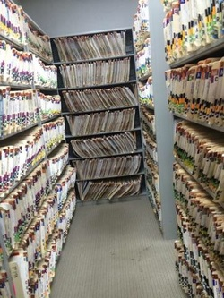

Honesty and integrity is just as important because if you are not straight forward, the problem can only get worse. Although truthfulness can be hard, it’s better to hurt with the truth rather than cover up with a lie. That quote means a lot to me and what I do every day at work because everyone has their own way of seeing things. If you believe something does not look right, I would not be nervous to mention it, even if I am wrong. My co-workers really appreciate that I am asking questions and coming in and going straight to work. As soon as I walk into the filing room, I grab as many files as I can grab and put as many as I can away, although it is very tiring.
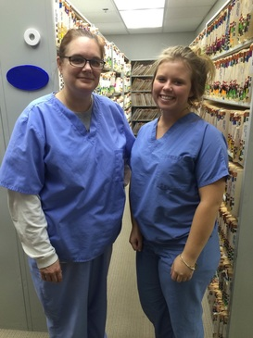
Dependability is not just important, but it is expected from your employer. I believe that dependability and responsibility are similar. I have never been late to work, because it is a priority to me to show up at work on time. Now that I have a job that will give me some experience that I will use in the future, I put all the time and two senses together into my work. I have one goal, and that it is to never have someone regret that they ever hired me. I know that I respect the doctors and medical assistances, and I just hope to show them that they should appreciate all the hard work I do, even if it does not benefit them. I know I work hard, and even if no one sees it, I respect each person and their role at work, even though it does not help or benefit me in any way.
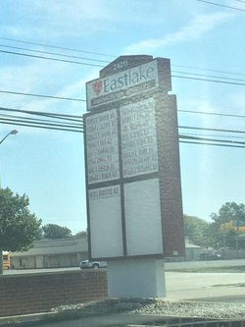
This class has changed me as a person by helping me face problems that I have to solve, with or without help. As I learned each week a new way to do something, I became very familiar with all the techniques they do. One moment that I will never forget is that a patient had an accident down the hall by a room, as I watched all the doctors helping him and cleaning up the mess. I noticed that they all worked together, although how gross the job was. I would recommend this job to a friend or someone who is considering going to school to work in the medical field. You get to meet a lot of people along the way and you get to work with real life patients of your office. My favorite part of my job is being able to help and be a part of the Eastlake Cardiovascular team.

RUBRIC FOR ESSAY (25x4=100 points)
CATEGORY | Advanced (5) | Proficient (4-3) | Basic (2) | Below Basic (1-0)
Appearance +  Pictures (3) | Appearance is aesthetically appealing, neatly organized and information is quite accurate. | Appearance has some visual appeal, organized and information is precise. | Appearance has some graphic details pleasing to the eye, organization skills and accuracy is semi-evident. | Graphic details and organizational skills are completely nonexistent.
Quality of Work  Responds to all THREE SKILL areas | Information clearly relates to the main topic. It includes SEVERAL supporting details and/or examples. | Information clearly relates to the main topic. It provides FEW supporting details and/or examples. | Information clearly relates to the main topic. No details and/or examples are given. | Information has little or nothing to do with the main topic.
Vocabulary/Spelling | Excellent choice of creative language (vocabulary), sentence variety and structure.  0-1 spelling errors | Good word choice (vocabulary), sentence variety and structure.  2-3 spelling errors | Very limited word choice (vocabulary), repetitive sentence types, some errors in the sentence structure.  4-5 spelling errors | Poor word choice (vocabulary), list-like sentences with a significant amount of errors.  6+ spelling errors
Introduction Paragraph | Provides both an incredibly powerful and convincing hook, background, thesis. | Missing one important component, but compelling. | Missing more than one important component. Rushed. | There is no introduction. The paper just begins.
Closing Paragraph | Effective closure that answers all asked questions. | Missing one important component, but compelling. | Missing more than one important component. Rushed. | There is no conclusion. The paper just ends.

