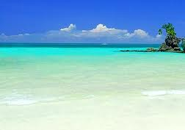

Fortunate
If you are fortunate you are lucky. I am very fortunate for the things that I have in my life. I have everything I need to live, my mom provides me with the things I need. This word is powerful to me because a lot of people aren’t as fortunate as I am.

Pleased
If you are pleased you are happy. I am very pleased about my life. This word is powerful to me because a lot of people aren’t happy and hate life but I’m just fine. Nothing really bothers me; I just go with the flow.

Obligated If you are obligated you are committed to do something. This word is powerful to me because I am obligated to do a lot of things but most I do not accomplish. I’m going to start accomplish anything that I am obligated to do. You can’t just say you’re obligated to do something and not do it.

